CS 255 System Design Document Template

UML Diagrams

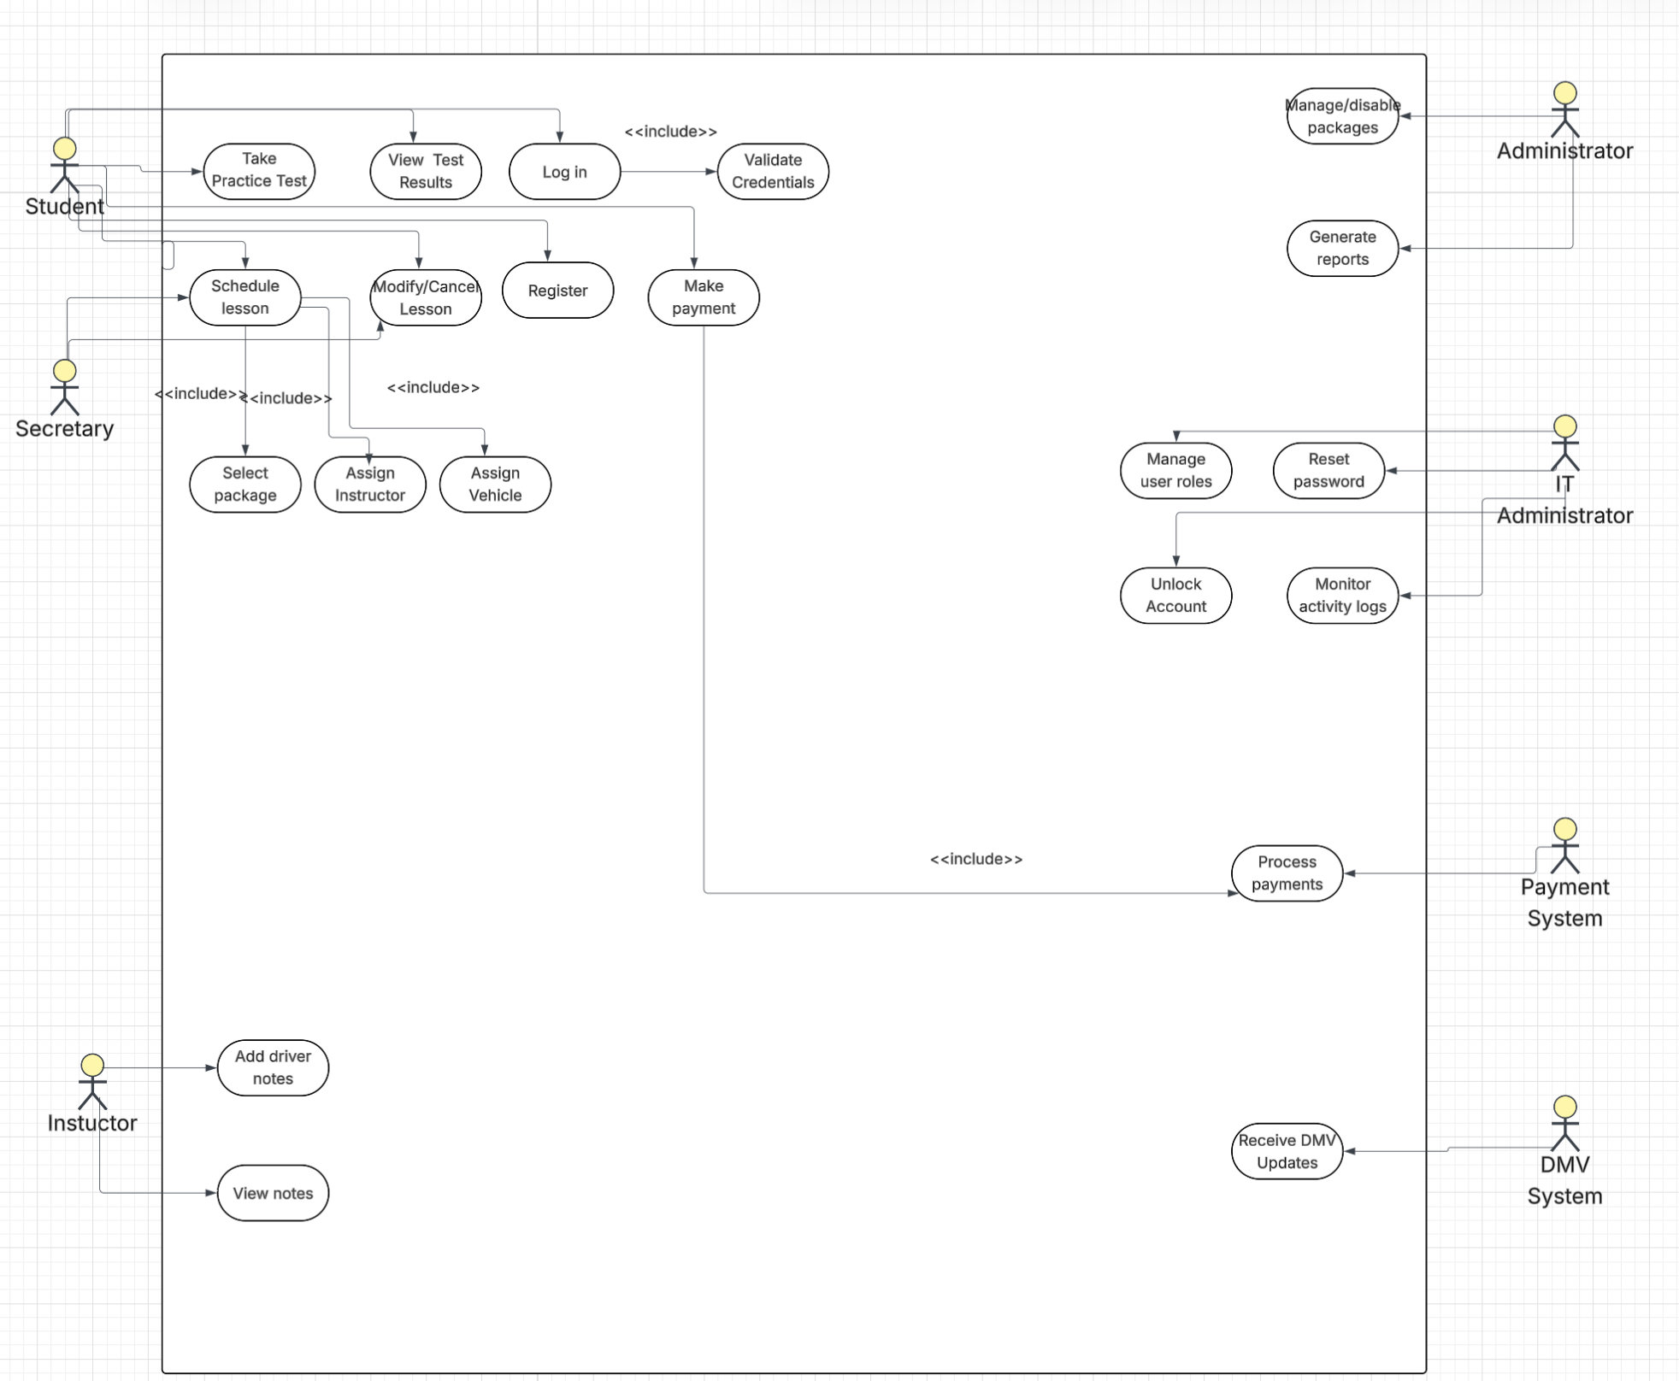
UML Use Case Diagram

UML Activity Diagrams
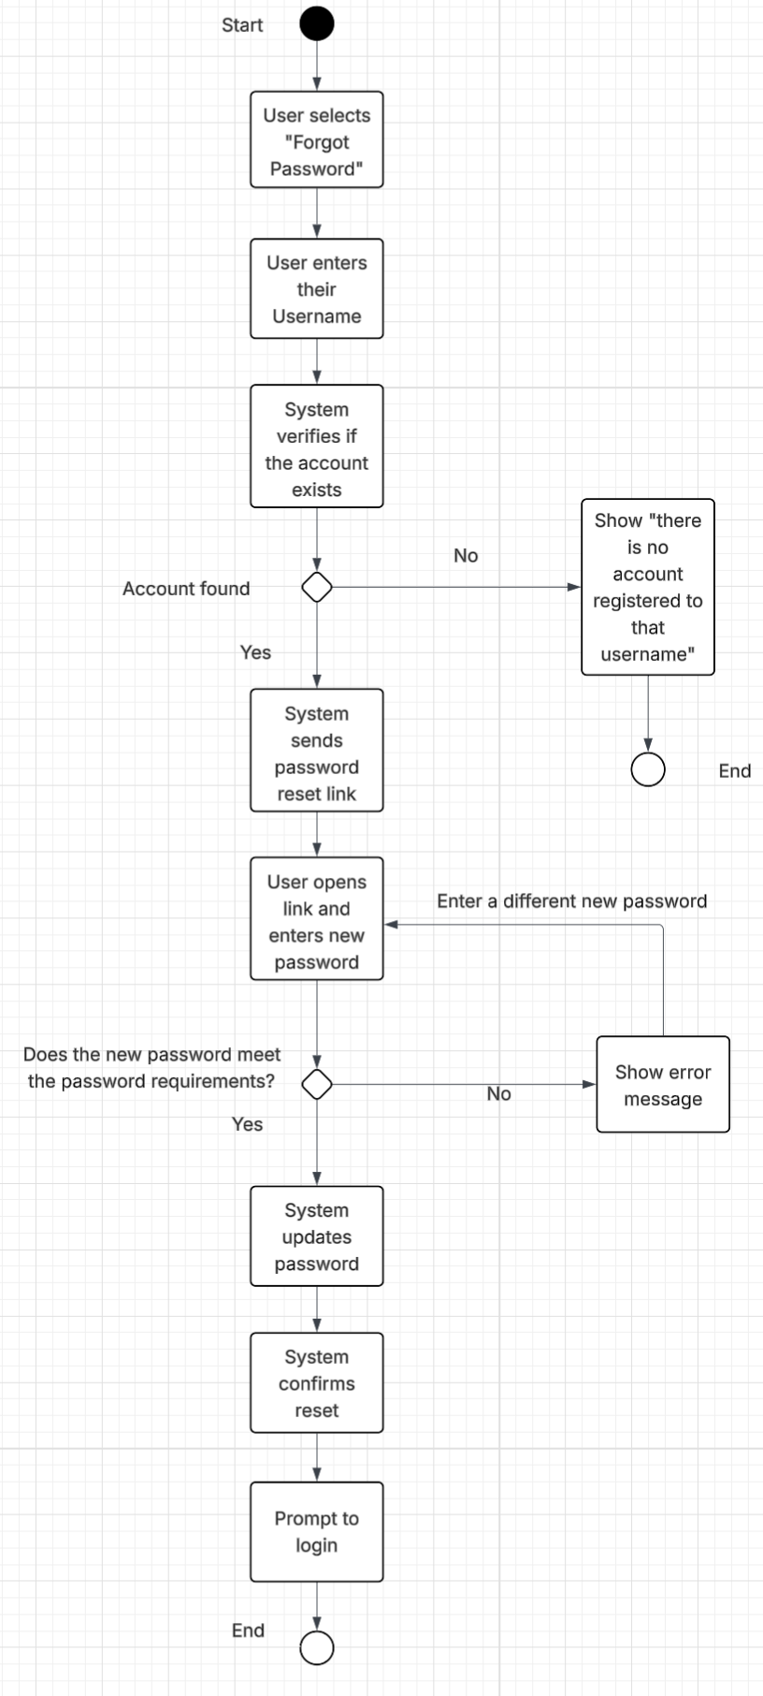
[You were asked to choose two use cases and create two activity diagrams, one for each use case. Please insert both of your activity diagrams here. Check to make sure that you included appropriate components and symbols and that your design meets the client’s needs.]
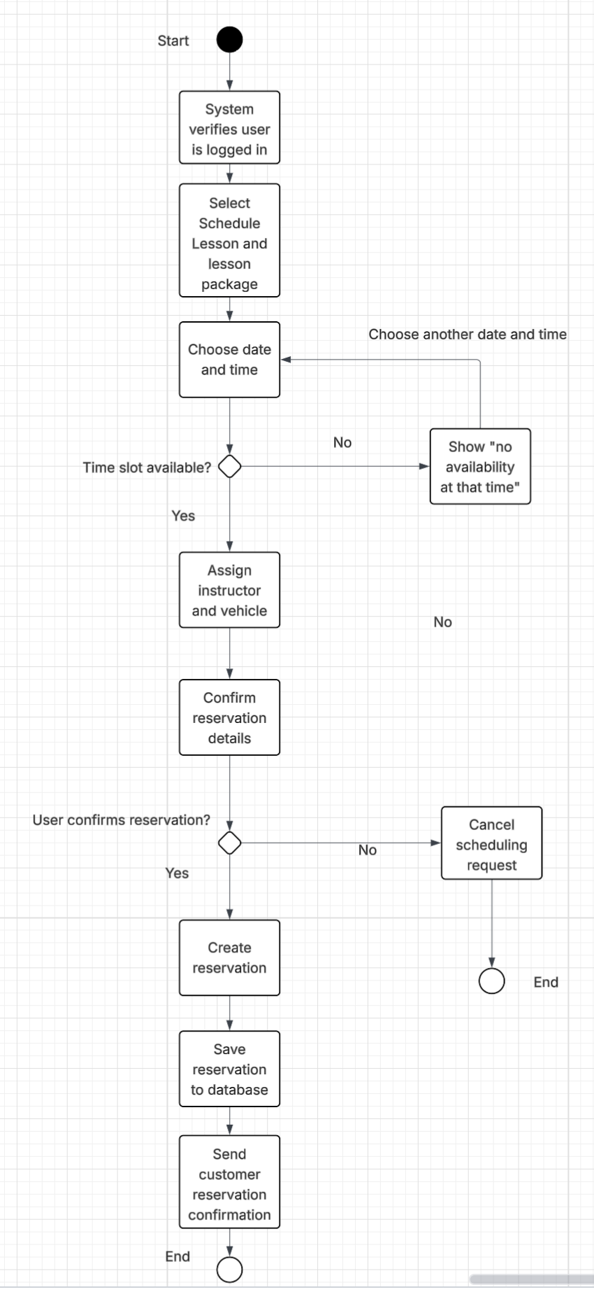

Schedule Lesson Use Case Reset Password Use Case

UML Sequence Diagram:
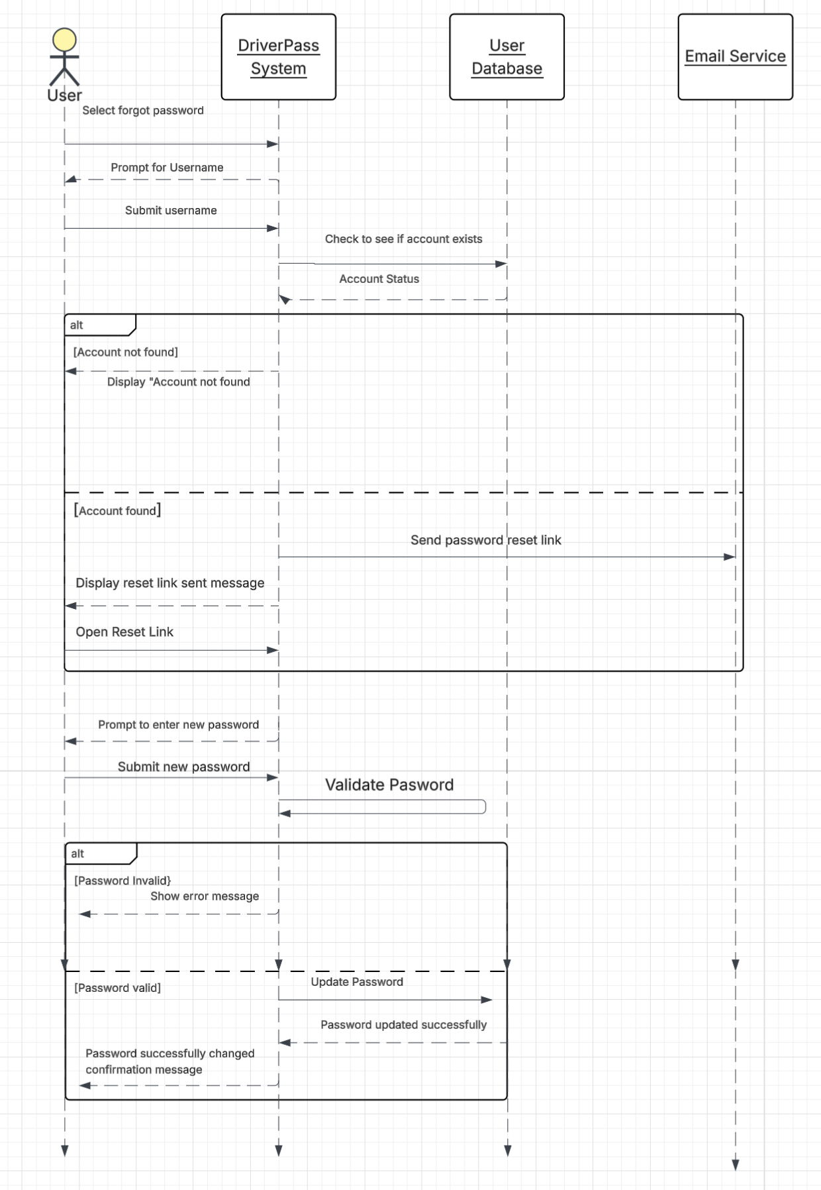

Reset Password Use Case Sequence Diagram

UML Class Diagram

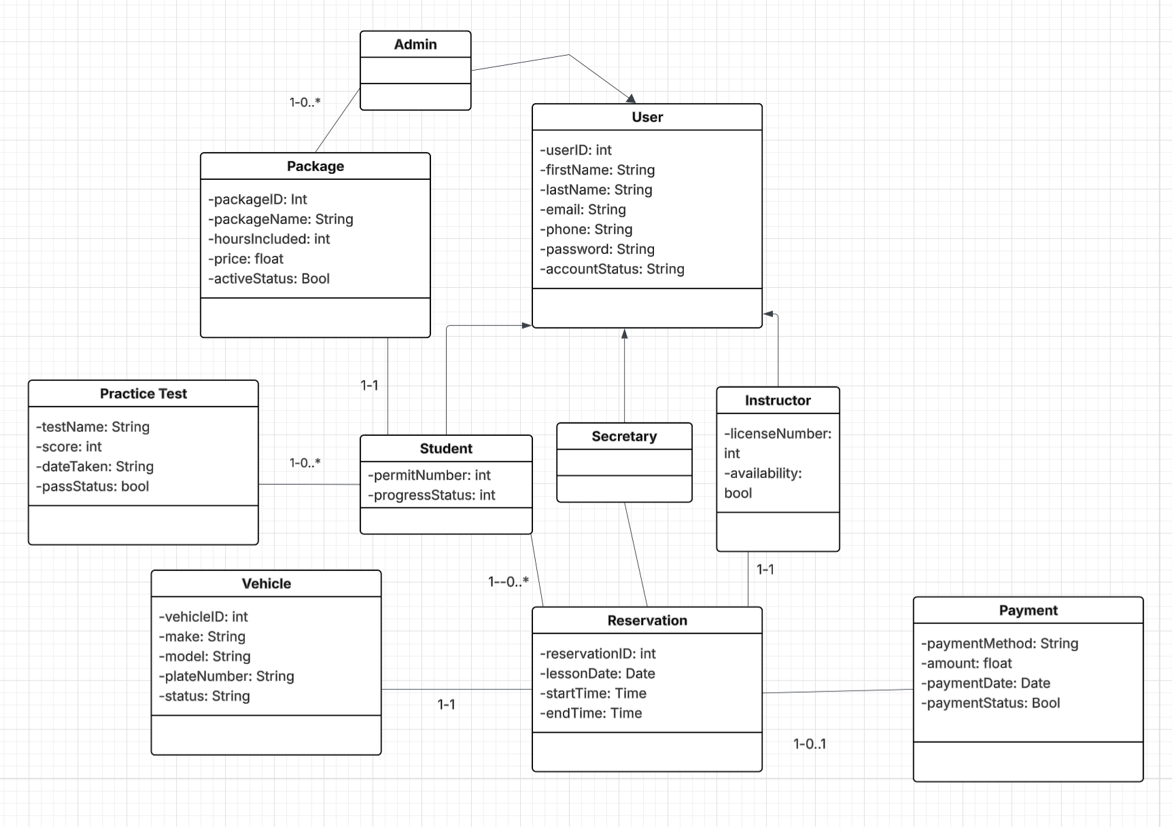

Class Diagram

Technical Requirements
[Based on the diagrams you have created, describe the technical requirements of your system. These requirements should address the required hardware, software, tools, and infrastructure necessary for your system design.]

Based on the UML diagrams I created for DriverPass, the following technical requirements are needed for the system to function as intended:
Hardware: The DriverPass system will operate as a cloud based web application. All users will need access to a desktop computer, phone, tablet, or laptop. They will also need a stable internet connection and access to a web browser. On the Organizational side DriverPass will need cloud hosted servers and a secure database to store information.
Software: The DriverPass System will need web application framework, a database management system to store data, secure authentication to protect user accounts, email integration service for password resets any notifications, and payment processing to handle payments.
Tools: To build and maintain the system the tools needed will be an IDE to build in, testing tools to test system functionality and security, and UML modeling tools like Lucidchart to maintain system documentation.
Infrastructure: The system must be hosted on a secure cloud platform that can support multiple users at once. The infrastructure must secure database storage, automatic backups in case of failure, and role based access control so that users can only access features according to their role.

